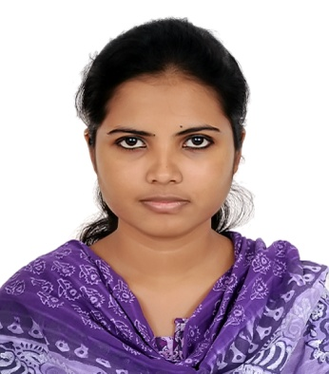**Nusrat Amin Khan**

Contact: GP.CHA/171, TB Gate Mohakhali, Dhaka-1212

Cell: 01719380770, 01670461226

Email: [rat.nos@live.com](mailto:rat.nos@live.com)

**Career Objective:**

As a student of Business Administration I would like to pursue a challenging career path relevant to finance and marketing by proving myself best in the reputed organization through my good analytical skills and hard working ability, which will provide me the learning opportunities to grow and excel.

**Education:**

**Bachelor of Business Administration** (Session 2010-2013)

Major: Finance and marketing

CGPA: 3.83/4.00

Name of Institute: BRAC University

**A’ Levels** (Session 2009)

Major: Business Studies

CGPA: 3.00/5.00

Private candidate

**O’ Levels** (Session 2007)

Major: Science

CGPA: 3.65/5.00

Bangladesh Elementary School CTG

**Skills:**

Computer skills:

* Proficient in MS Word, Excel PowerPoint (2003 and 2007) and SPSS software.
* Knowledge in Internet browsing.

Language skills:

* Can fluently write, read listen and speak in Bangla and English.

Interpersonal skills:

* A quick learner with good analytical skills and a sharp mind.
* Enthusiastic, creative team player with strong problem solving and organizational skills.
* Can work well under pressure.
* Adept at accepting responsibility, implementing decisions, attending to details, setting and meeting deadlines punctually and with full cooperation**.**

**Accomplishments:**

* Got Vice chancellor and Dean Certificate 9 times from BRAC University for good results from 2011-2013
* Was one of the finalists in ROBI Young Talent Program in the year 2013.
* Got Certificate for being one of the semifinalists in “Horlicks Genius Bangladesh” in the year 2005.
* Got Certificate for participating in “Math Olympiad” in the year 2003.

**Volunteer Activities:**

* Organized seminar on “Entrepreneurship Development in Bangladesh Prospects and Problems” in the year 2011. My responsibility was to arrange the seminar and decorate it.
* Organized seminar on “Real Leadership” in the year 2012. I had to arrange the seminar, I was even the host of the seminar
* Organized seminar on “Future of Agro-Business in Bangladesh” in the year 2010. I had to decorate the hall where the seminar took place.

**Interest and Hobbies:**

* Reading Novels
* Watching Movies
* Travelling.
* Interested to gain knowledge related to finance and marketing through newspapers, articles and many more.
* Interested to work in team to enhance my learning.

**References:**

Samina Haque MD Anisur Rahman

Senior Lecturer Proprietor

BRAC University Anis Neon Sign

Email: [samina@bracu.ac.bd](mailto:samina@bracu.ac.bd) Email: [anisneon@yahoo.com](mailto:anisneon@yahoo.com)

Cell: 01713040596 Cell: 01817217777